Learners have to come up with a Report to support the answers to the following questions and suggestions

Objective Questions

- Does any table have missing values or duplicates? If yes how would you handle it ?

Final Answer
The Chinook database should be checked for:
- Missing (NULL) values in optional columns.
- Duplicate business records.
- Duplicate primary keys (which should not exist).

Aproach
- Check NULL values.
- Check duplicate primary keys.
- Check duplicate customer records.
- Recommend data-cleaning actions.

Charts & Tables (if any):
Missing values in Customer & Track
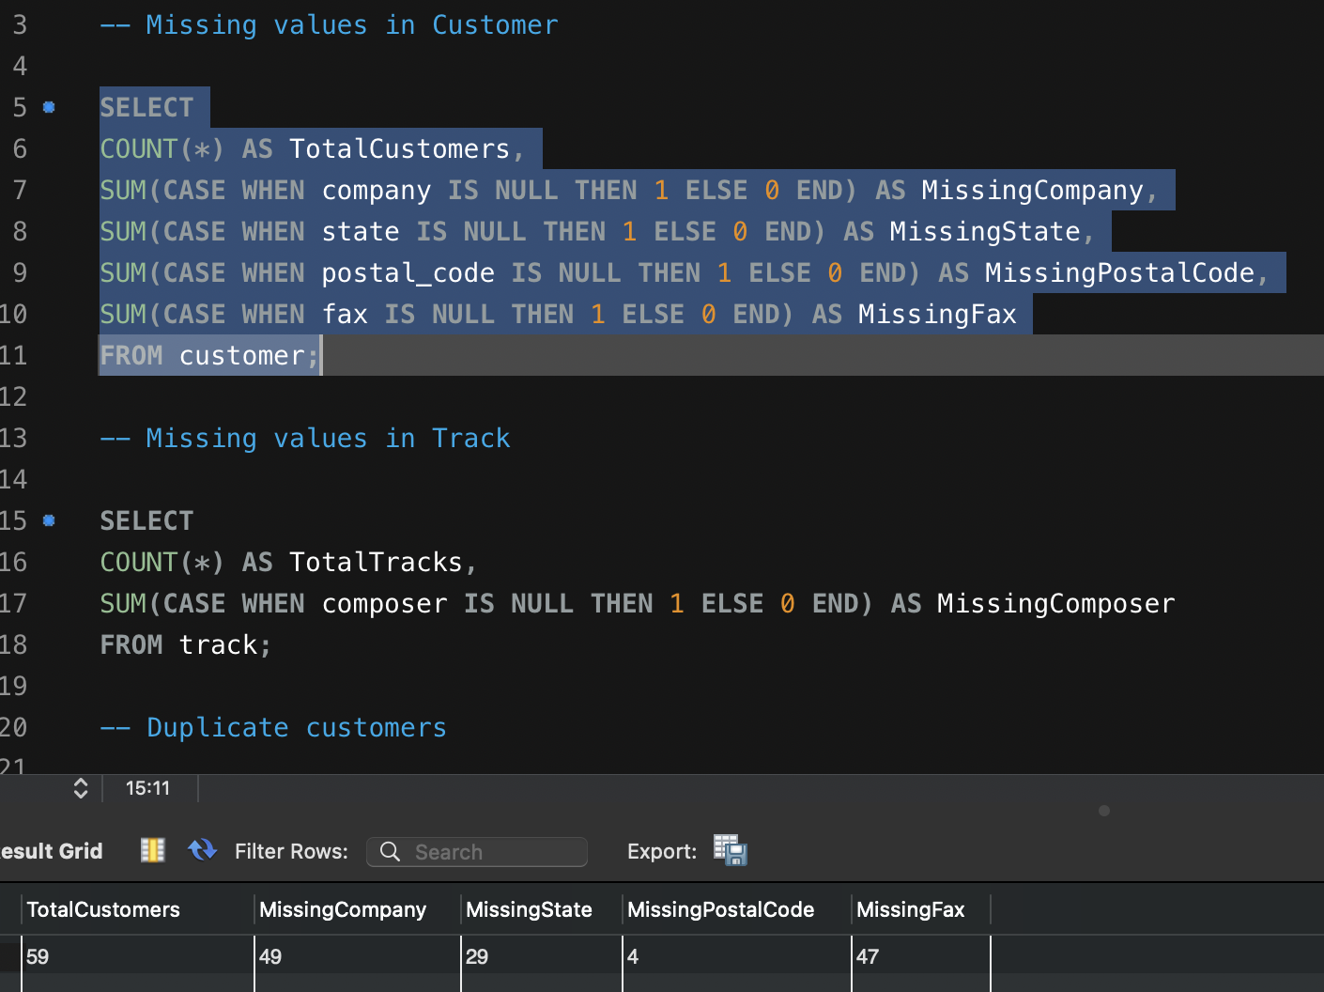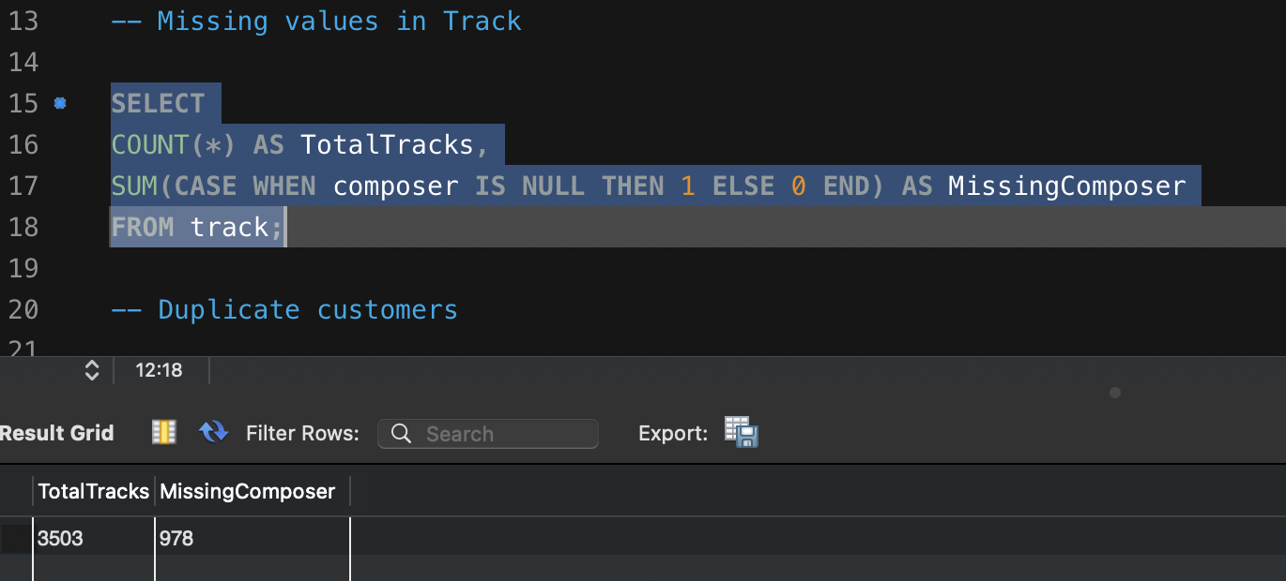
Duplicate customers, Invoice IDs
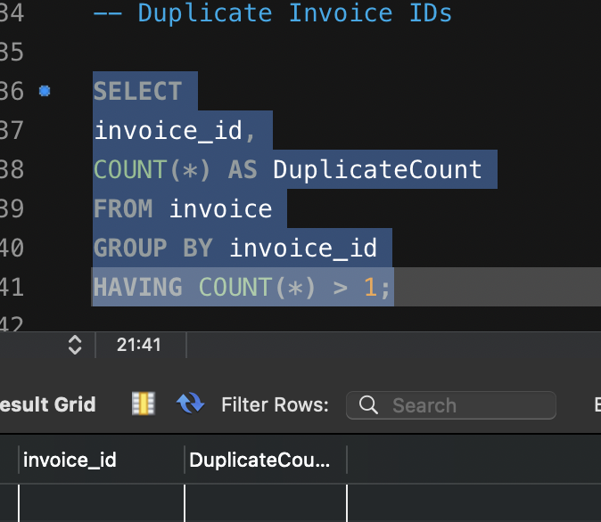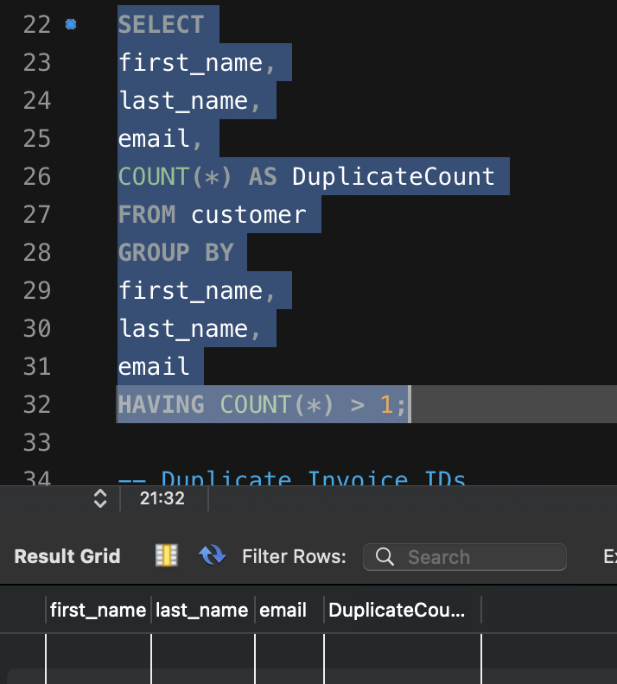

- Find the top-selling tracks and top artist in the USA and identify their most famous genres.

Final Answer
Identify:
- Top-selling tracks
- Top-selling artists
- Best-selling genres
- Revenue generated in the USA

Aproach
NA

Charts & Tables (if any):

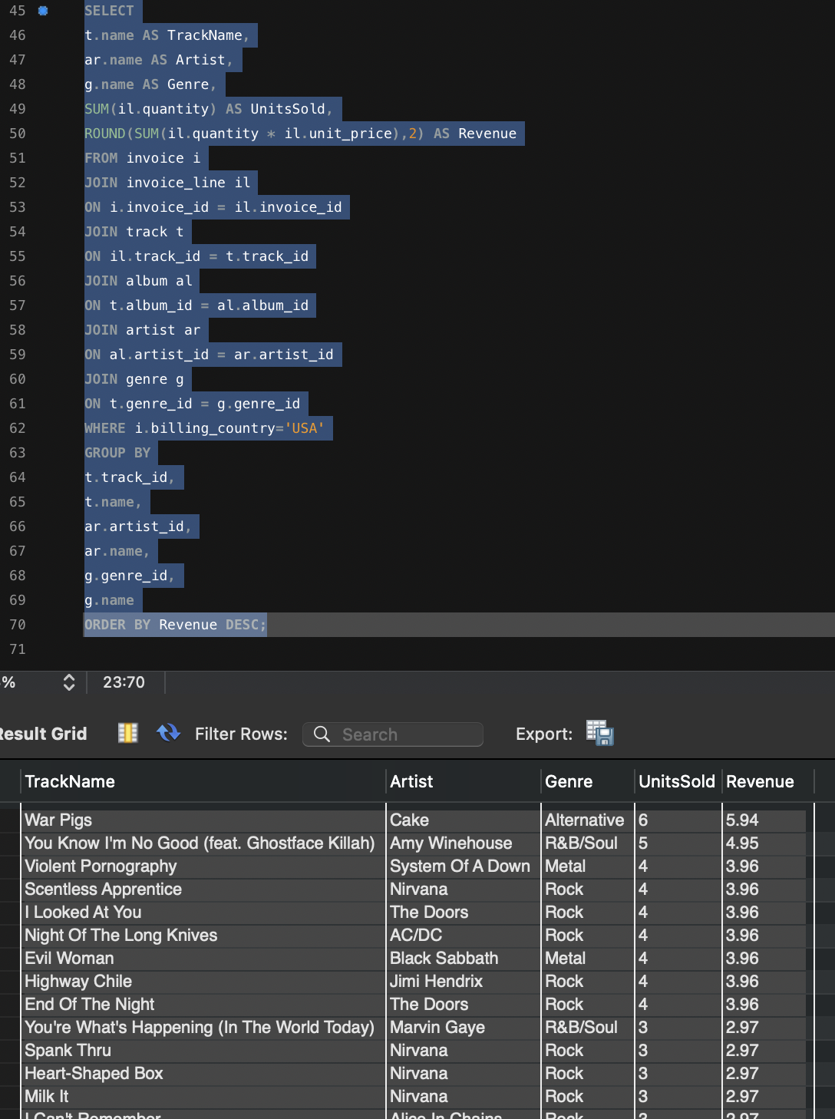

- What is the customer demographic breakdown (age, gender, location) of Chinook's customer base?

Final Answer
The Chinook database contains location information only.
The following fields are not available:
- Age
- Gender
Therefore, customer demographics can only be analyzed by geographic location.

Approach
Group customers by:
- Country
- State
- City

Charts & Tables
- Country-wise Customers
- State-wise Customers
- City-wise Customers
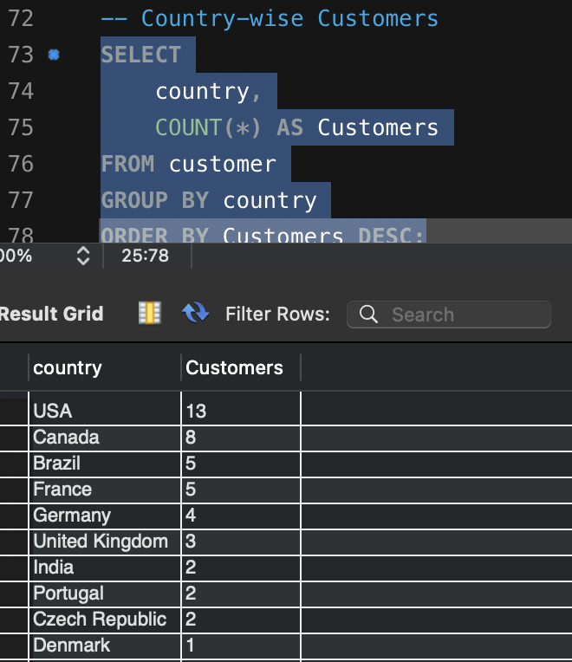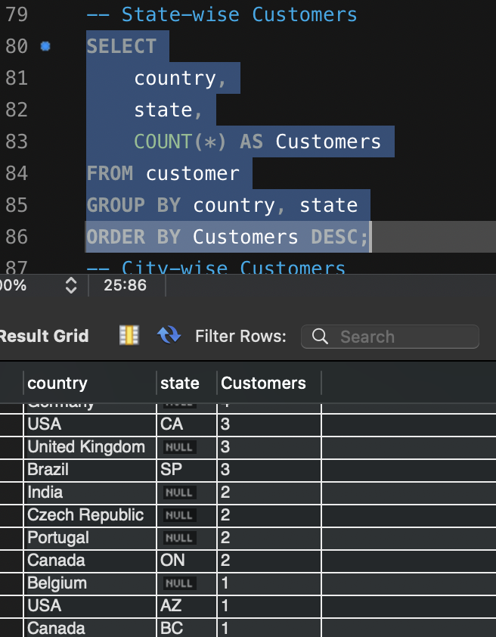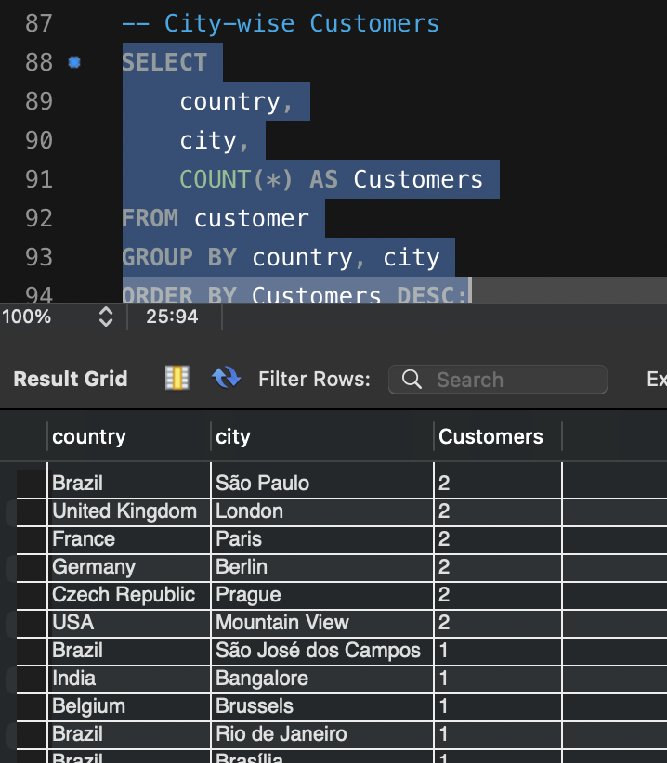

- Calculate the total revenue and number of invoices for each country, state, and city:

Final Answer
Revenue by geographic location identifies the strongest markets and supports regional business decisions.

Approach
Aggregate invoice data by:
- Country
- State
- City

Charts & Tables
- Revenue by Country
- Revenue by State
- Revenue by City
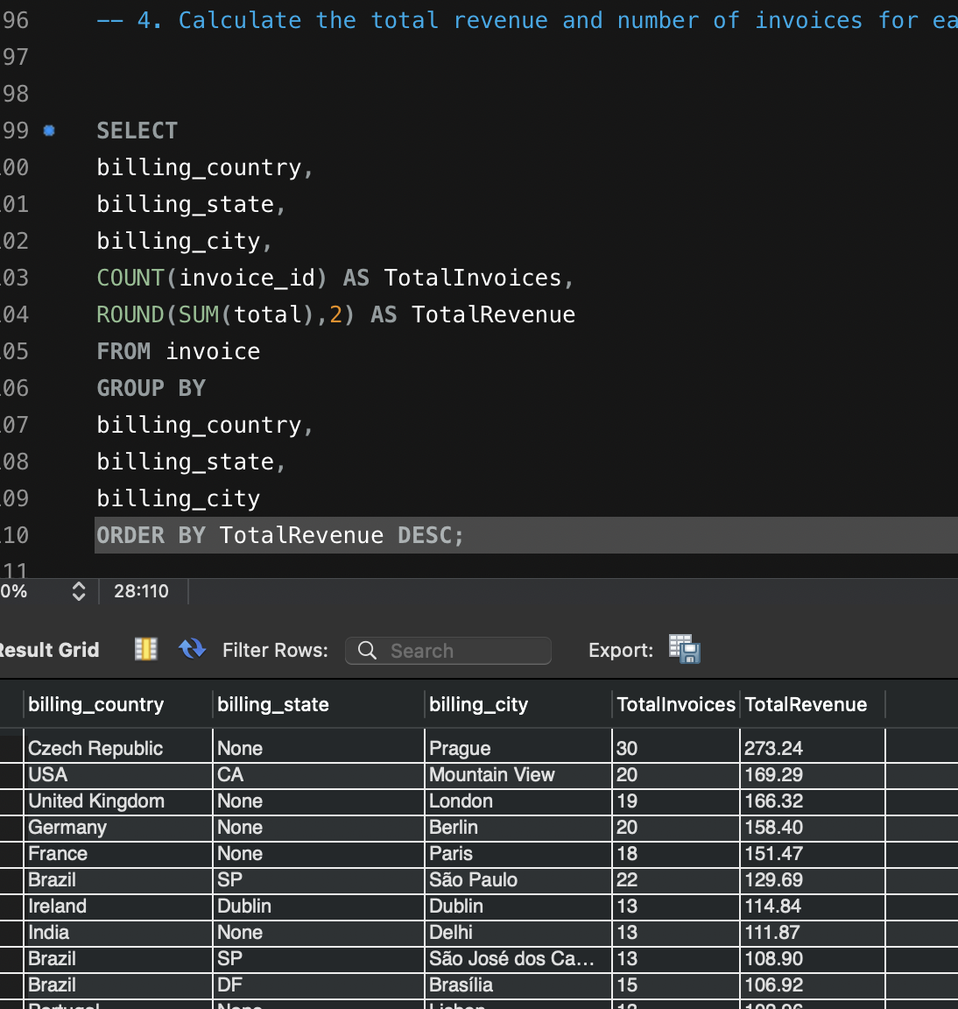

- Find the top 5 customers by total revenue in each country

Final Answer
Identify the highest-value customers in each country based on total invoice value.

Approach
- Calculate total revenue per customer.
- Rank customers within each country using DENSE_RANK().
- Return the top five customers.

Charts & Tables
- Top Customers by Country
- Customer Revenue Leaderboard
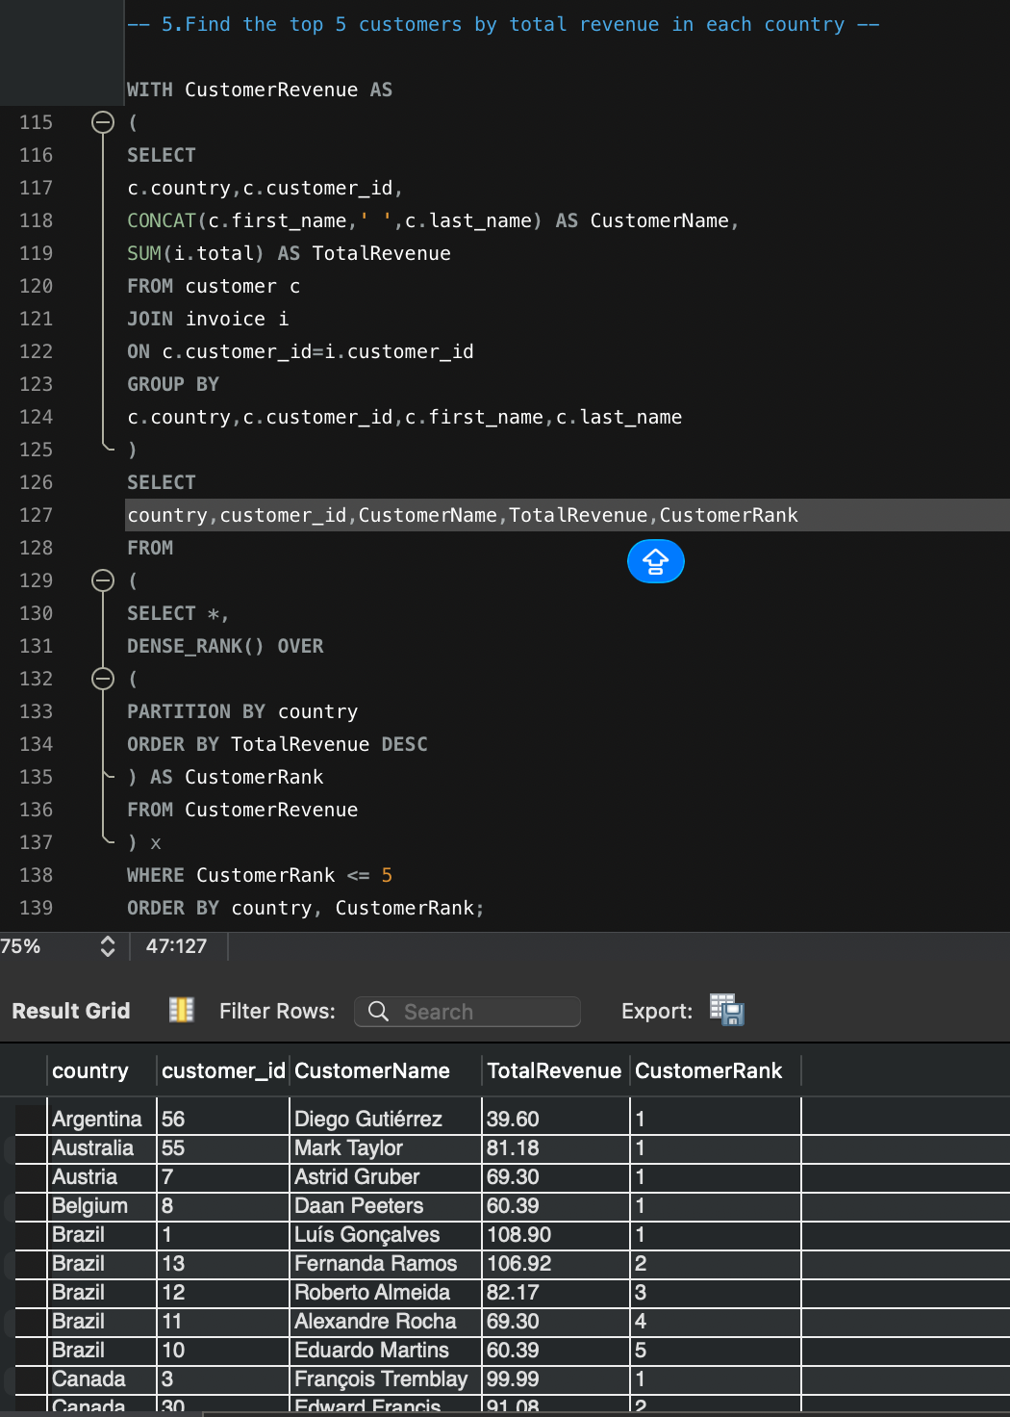

- Identify the top-selling track for each customer

Final Answer
Determine each customer's most frequently purchased track based on purchase quantity.

Approach
Join: Customer – Invoice - Invoice_Line – Track ,
Calculate purchase totals and rank tracks per customer.

Charts & Tables
- Customer Favorit Tracks
- Top Purchased Tracks by Customer
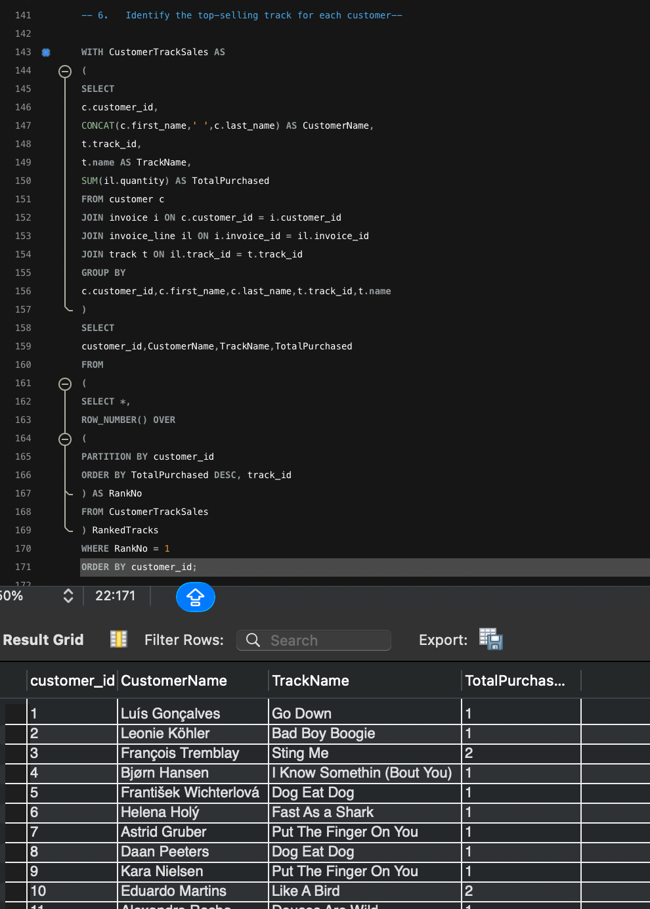

- Are there any patterns or trends in customer purchasing behaviour (e.g., frequency of purchases, preferred payment methods, average order value)?

Final Answer
The Chinook database allows analysis of:
- Purchase Frequency
- Average Order Value (AOV)
- Average Basket Size
Preferred Payment Method cannot be analyzed because no payment method column exists in the Invoice table.

Approach
- Count invoices for each customer.
- Calculate average invoice value.
- Calculate average number of tracks purchased per invoice.
- Classify customers based on purchase frequency.

Charts & Tables
- Customer Purchase Frequency
- Average Order Value
- Basket Size Distribution
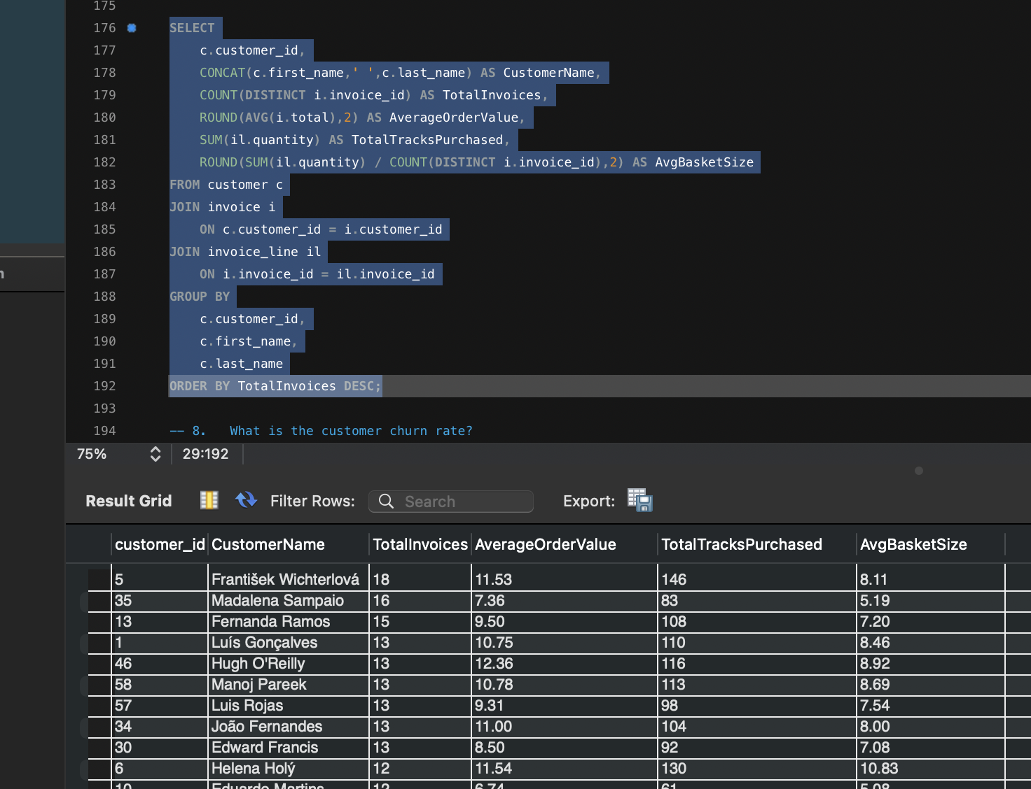

- What is the customer churn rate?

Final Answer

Customer churn rate is 37.29.

Approach
- Find latest invoice date.
- Find each customer's latest purchase.
- Calculate inactive customers.
- Compute churn percentage.

Charts & Tables
- Active vs Churned Customers
- Churn Percentage
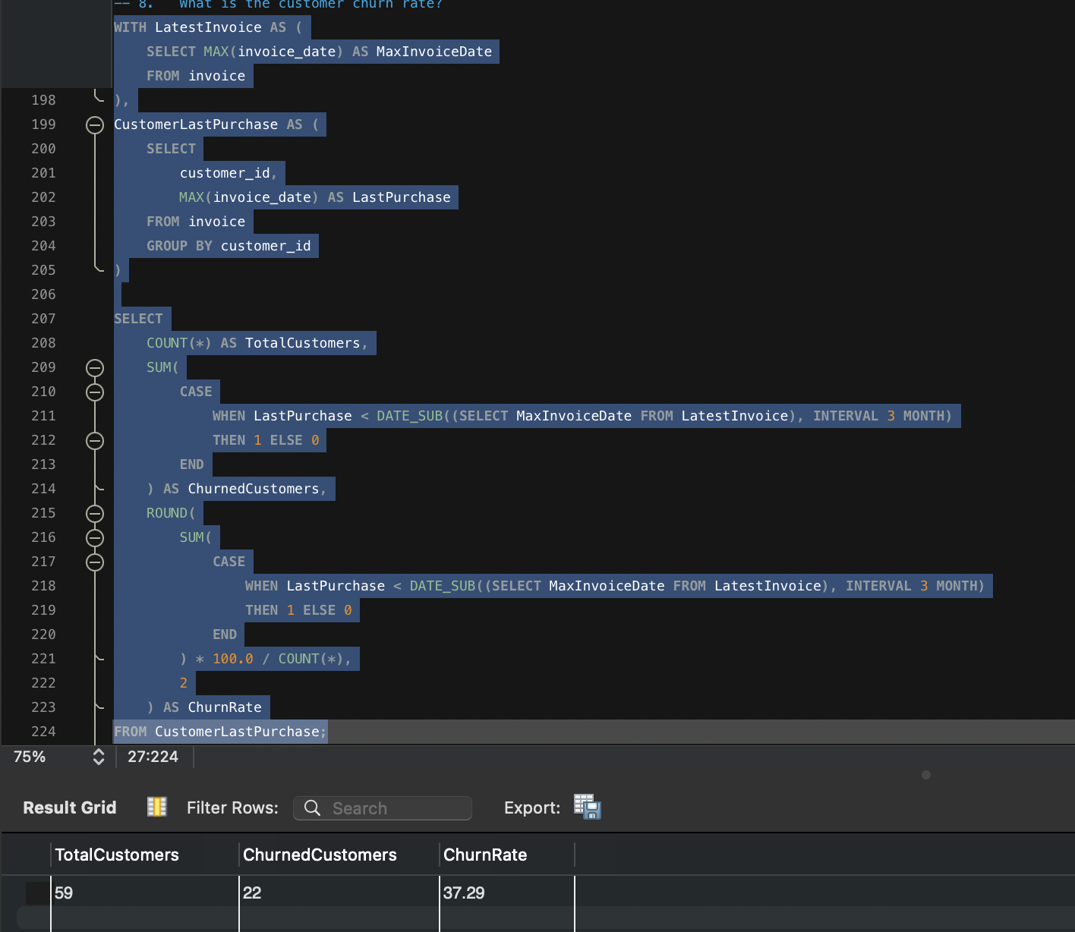

- Calculate the percentage of total sales contributed by each genre in the USA and identify the best-selling genres and artists.

Final Answer
The analysis measures each genre's contribution to USA sales and identifies the highest-performing artists within those genres.

Approach
- Join Invoice → Invoice_Line → Track → Genre → Album → Artist.
- Filter USA invoices.
- Calculate revenue and percentage contribution.

Charts & Tables
- Genre Contribution (%)
- Top Artists by Revenue
- Genre Revenue Ranking
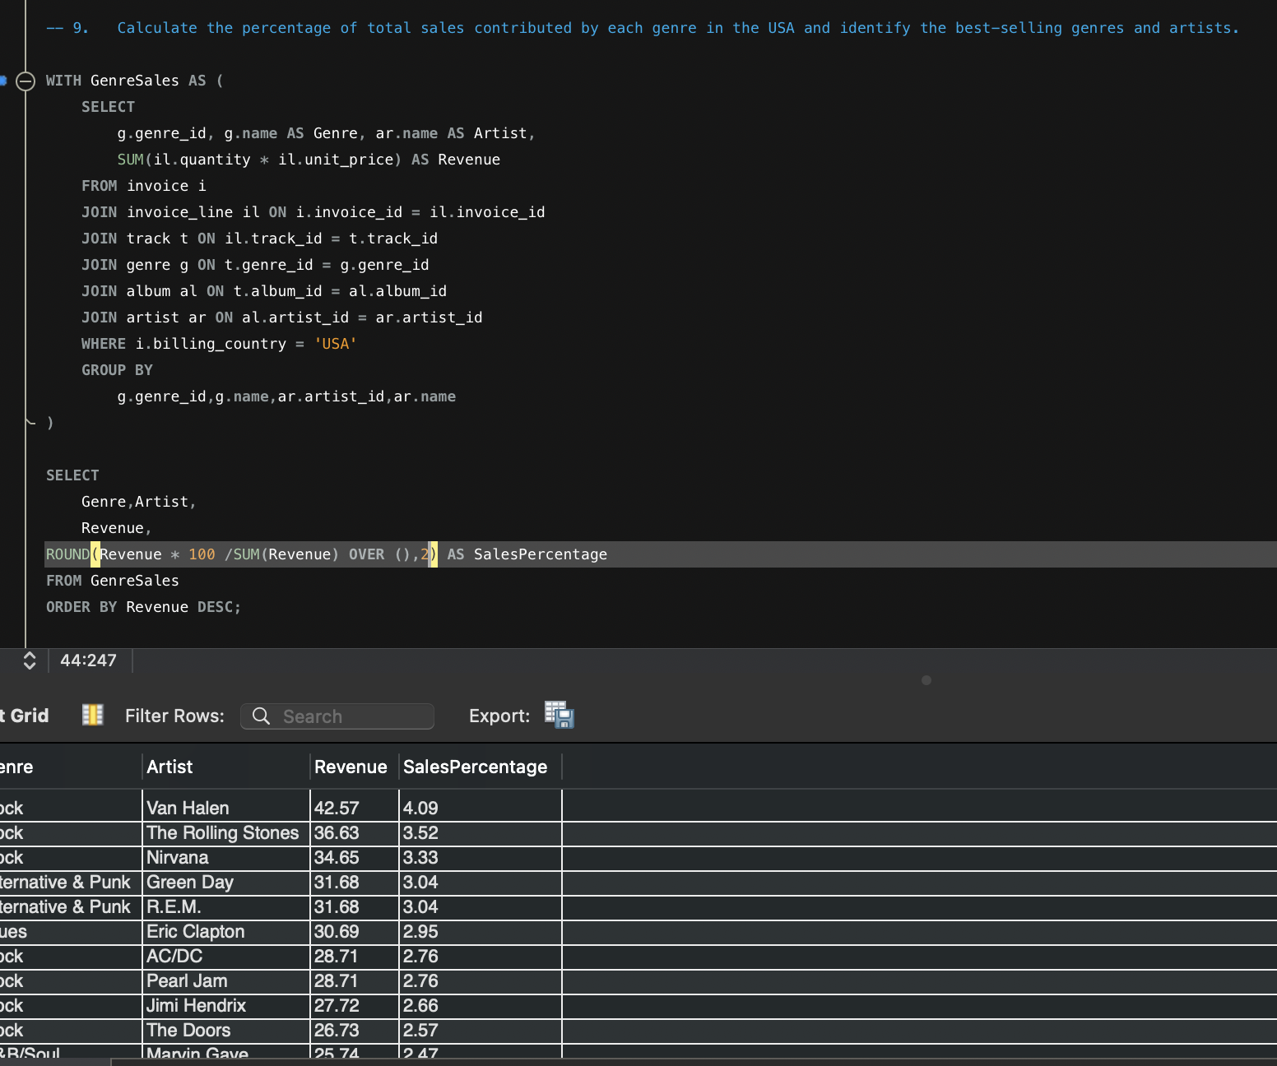

- Find customers who have purchased tracks from at least 3 different genres

Final Answer
Customers purchasing from multiple genres demonstrate diverse music preferences and are ideal candidates for cross-selling.

Approach
- Join Customer → Invoice → Invoice_Line → Track → Genre.
- Count distinct genres purchased.
- Return customers with three or more genres.

Charts & Tables
- Genre Diversity by Customer
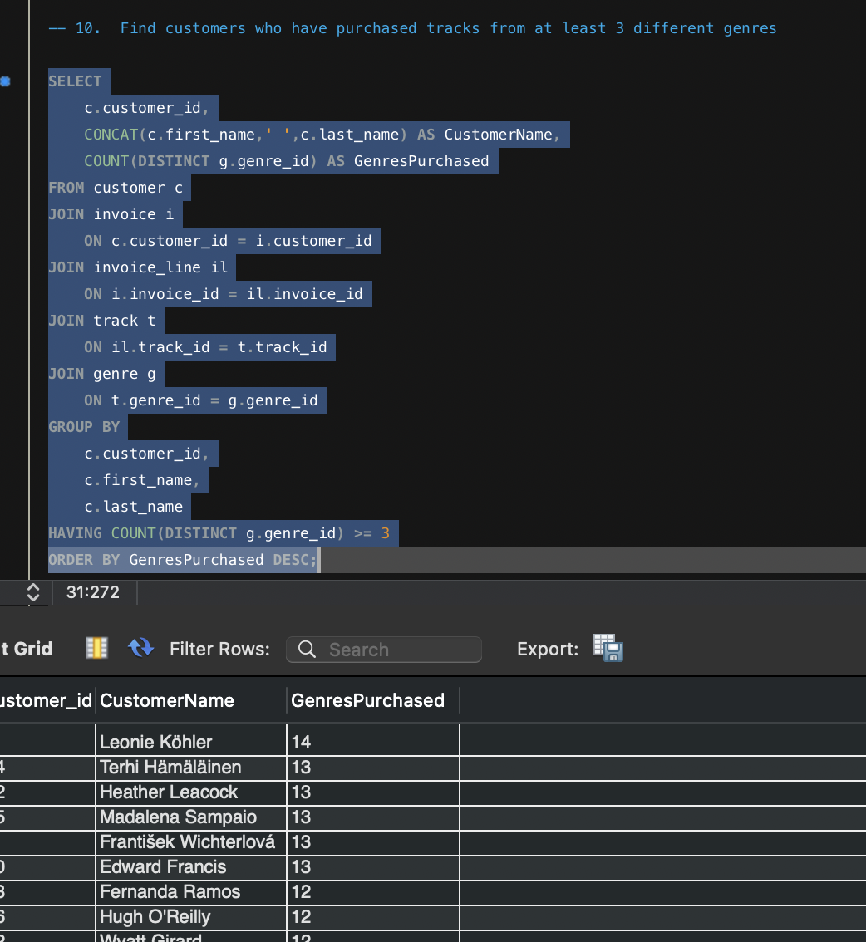

- Rank genres based on their sales performance in the USA

Final Answer
Genres are ranked based on total revenue generated from USA customers.

Approach
- Calculate revenue for each genre.
- Rank using DENSE_RANK().

Charts & Tables
- Genre Sales Ranking
- Revenue by Genre

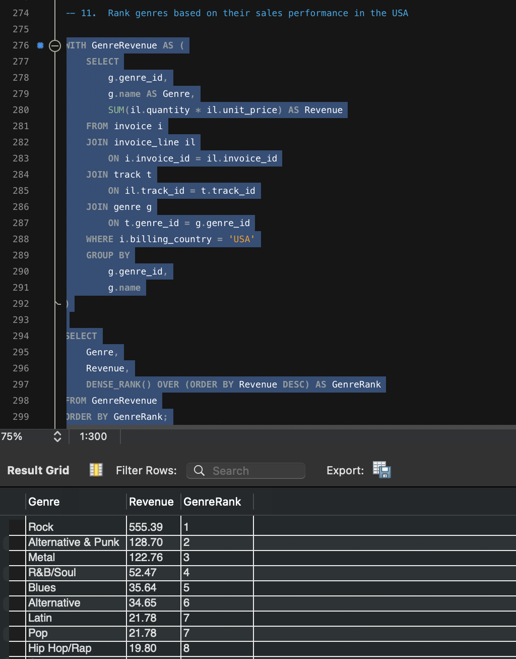

- Identify customers who have not made a purchase in the last 3 months

Final Answer
Customers whose most recent purchase occurred more than three months before the latest invoice date are considered inactive.

Approach
- Find latest purchase date.
- Compare each customer's last invoice date.
- Return inactive customers.

Charts & Tables
- Active vs Inactive Customers
- Last Purchase Date by Customer
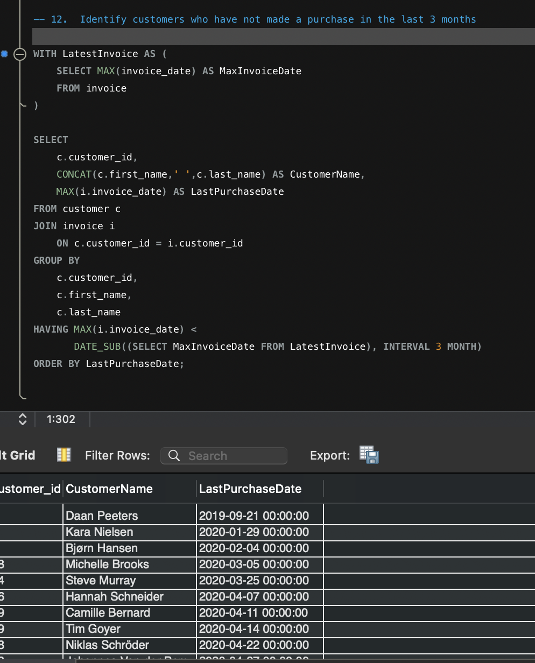

Subjective Questions

- Recommend the three albums from the new record label that should be prioritised for advertising and promotion in the USA based on genre sales analysis.

Final Answer
Since Chinook does not contain a Record Label table, the recommendation is based on top-selling albums in the USA. The three albums generating the highest revenue in the USA should be prioritized for advertising because they have already demonstrated strong customer demand.

Approach
- Filter invoices from the USA.
- Join Invoice → Invoice Line → Track → Album → Artist.
- Calculate album revenue.
- Rank albums and select the Top 3.

Charts & Tables
- Top 3 Albums by Revenue
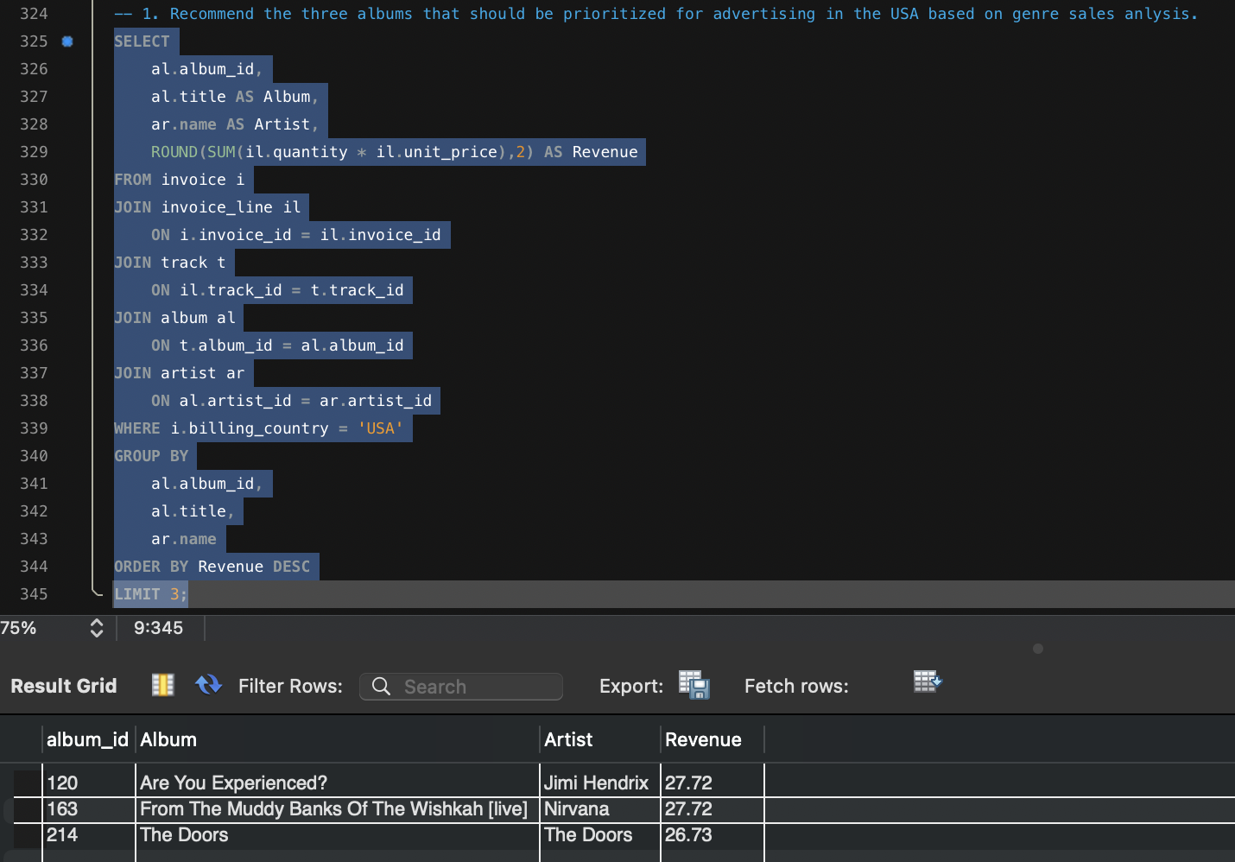

Insights
- Top-selling albums already have proven market demand.
- Promoting these albums is likely to maximize advertising return.
- Successful albums can be bundled with related releases.

Recommendations
- Prioritize marketing for the top three albums.
- Create artist-focused promotional campaigns.
- Feature these albums prominently on the store homepage.

- Determine the top-selling genres in countries other than the USA and identify any commonalities or differences.

Final Answer
This analysis compares genre performance outside the USA to identify regional music preferences and differences from the USA market.

Approach
- Exclude USA invoices.
- Calculate revenue by country and genre.
- Rank genres within each country.

Charts & Tables
- Top Genres by Country
- Country vs Genre Heatmap

- Customer Purchasing Behavior Analysis: How do the purchasing habits (frequency, basket size, spending amount) of long-term customers differ from those of new customers? What insights can these patterns provide about customer loyalty and retention strategies?

Final Answer
Customer tenure can be approximated using the date of the first purchase. Long-term customers are those with earlier first purchases, while new customers joined later.

Approach
- Determine each customer's first purchase date.
- Calculate:
  - Purchase frequency
  - Basket size
  - Total spending

Charts & Tables
- Spending by Customer Tenure
- Average Basket Size
- Purchase Frequency

Insights
- Long-term customers often have higher lifetime spending.
- Frequent purchasers contribute more revenue.
- Larger basket sizes indicate stronger engagement.

Recommendations
- Reward loyal customers with exclusive offers.
- Encourage repeat purchases through recommendations.
- Develop tiered loyalty programs.

- Product Affinity Analysis: Which music genres, artists, or albums are frequently purchased together by customers? How can this information guide product recommendations and cross-selling initiatives?

Final Answer
Product affinity identifies combinations of products frequently purchased together, supporting recommendation systems and cross-selling.

Approach
- Compare tracks purchased on the same invoice.
- Count track pairs.

Charts & Tables
- Frequently Purchased Together
- Network Diagram (optional)
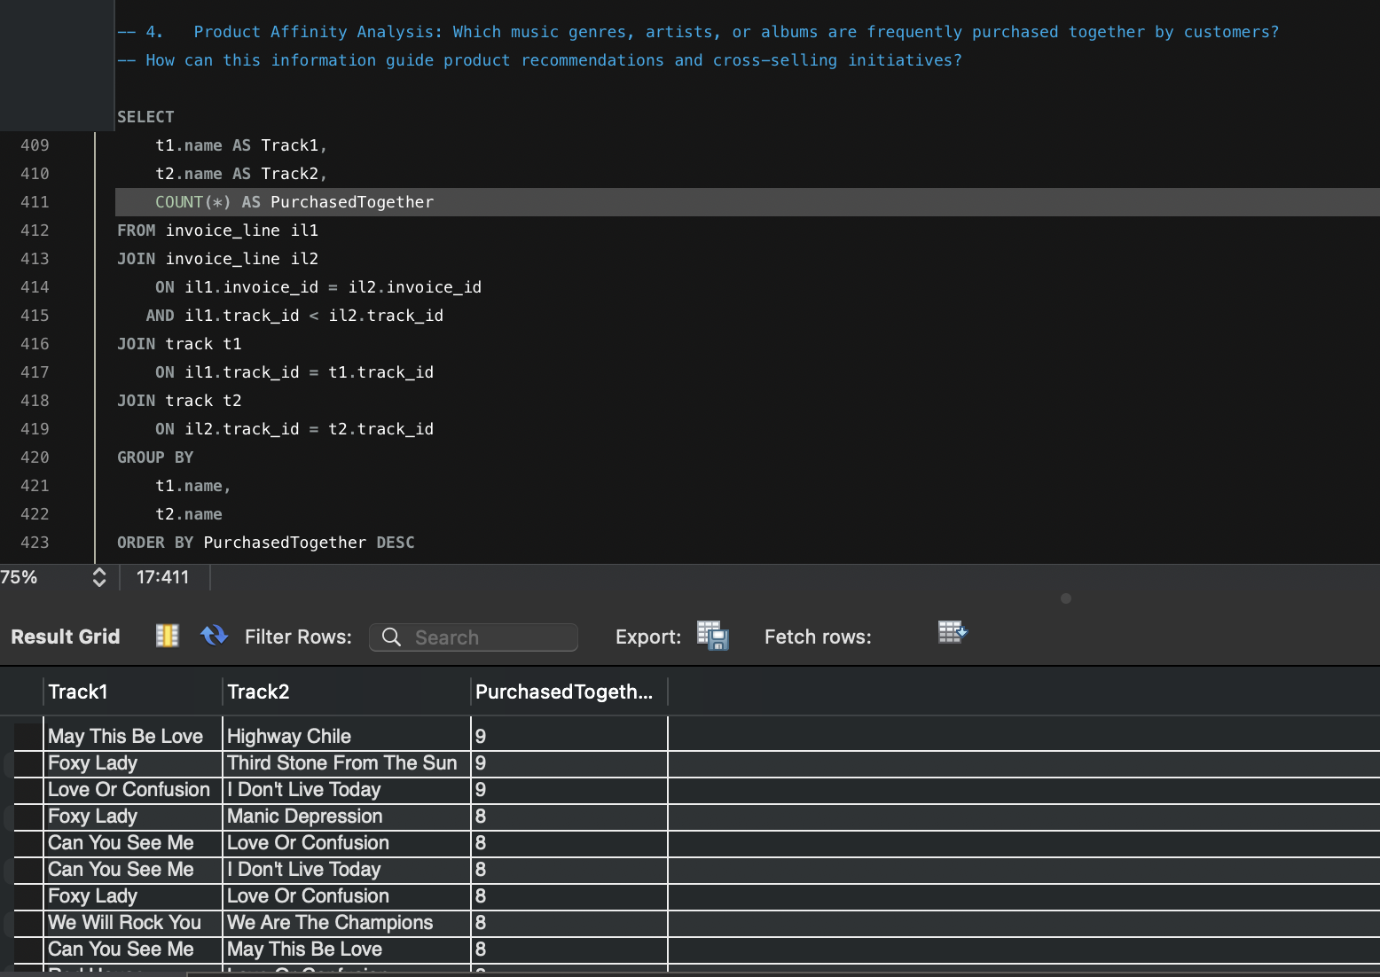

Insights
- Certain tracks are frequently purchased together.
- Affinity patterns can improve recommendations.
- Bundles may increase basket size.

Recommendations
- Implement "Customers also bought" suggestions.
- Bundle related albums.
- Recommend artists based on affinity

- Regional Market Analysis: Do customer purchasing behaviors and churn rates vary across different geographic regions or store locations? How might these correlate with local demographic or economic factors?

Final Answer
Customer behavior differs across countries and cities. Revenue and purchase frequency vary by region, while churn can be estimated using customer inactivity.

Approach
- Aggregate by country.
- Calculate:
  - Revenue
  - Customers
  - Average spending
  - Purchase frequency
Charts & Tables
- Revenue by Country
- Customer Distribution
- Average Spending
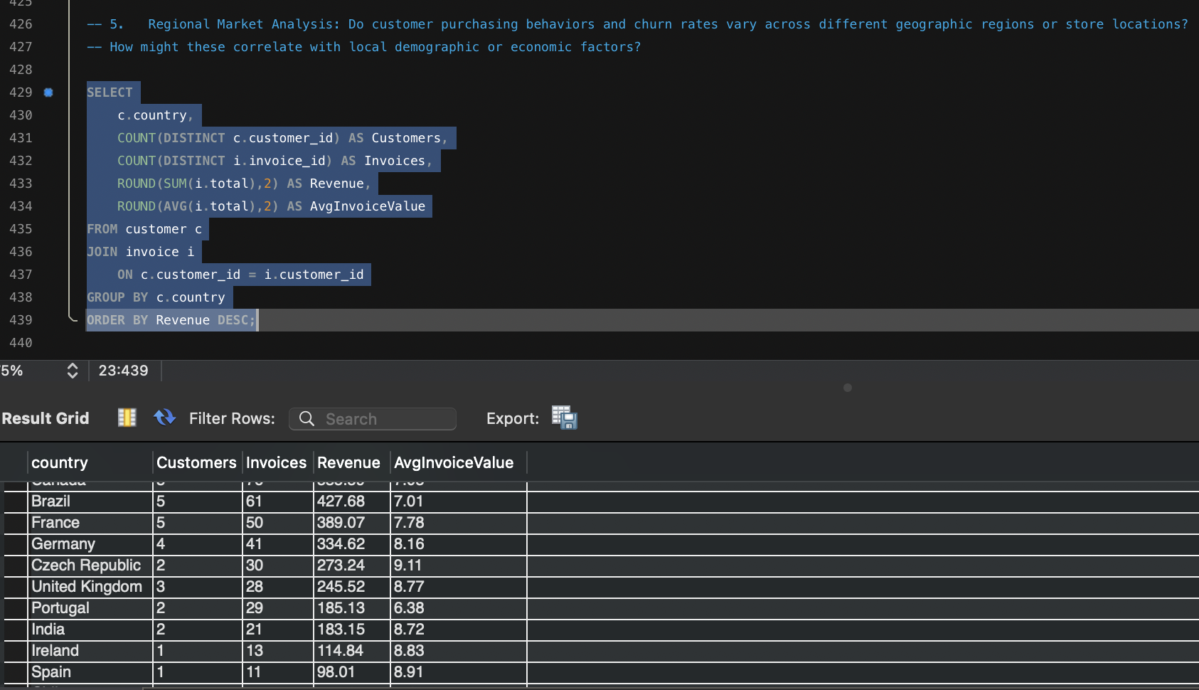

Insights
- Revenue varies significantly across regions.
- High-value regions deserve greater investment.
- Regional behavior informs expansion strategies.
Recommendations
- Increase marketing in top-performing regions.
- Design region-specific promotions.
- Monitor churn at the country level.

- Customer Risk Profiling: Based on customer profiles (age, gender, location, purchase history), which customer segments are more likely to churn or pose a higher risk of reduced spending? What factors contribute to this risk?

Final Answer
The Chinook database does not contain age or gender information. Risk profiling can therefore be based on:
- Purchase history
- Spending
- Geographic location
- Recency of purchases
Approach
- Find each customer's latest purchase.
- Calculate total spending.
- Identify customers with low spending or long inactivity.

Charts & Tables
- Customer Risk Matrix
- Last Purchase Distribution

Insights
- Customers with older purchase dates are at greater risk of churn.
- Low-spending customers may require re-engagement.
- High-spending inactive customers are priority targets for retention.

Recommendations
- Create win-back campaigns for inactive customers.
- Provide personalized offers to high-value customers.
- Monitor purchase recency as a key retention metric.

- Customer Lifetime Value Modeling: How can you leverage customer data (tenure, purchase history, engagement) to predict the lifetime value of different customer segments? This could inform targeted marketing and loyalty program strategies. Can you observe any common characteristics or purchase patterns among customers who have stopped purchasing?

Final Answer
Since Chinook does not contain customer engagement metrics (e.g., website visits, app activity, email clicks), Customer Lifetime Value (CLV) can be estimated using:
- Customer Tenure (First Purchase → Last Purchase)
- Purchase Frequency
- Total Revenue
- Average Order Value
Customers with high spending, frequent purchases, and long tenure are considered High CLV Customers.

Approach
- Find first purchase date.
- Find last purchase date.
- Count invoices.
- Calculate total revenue.
- Calculate average order value.
- Segment customers using CASE.

Charts & Tables
- Customer Lifetime Value Distribution
- Customer Segmentation
- Revenue by Customer Segment
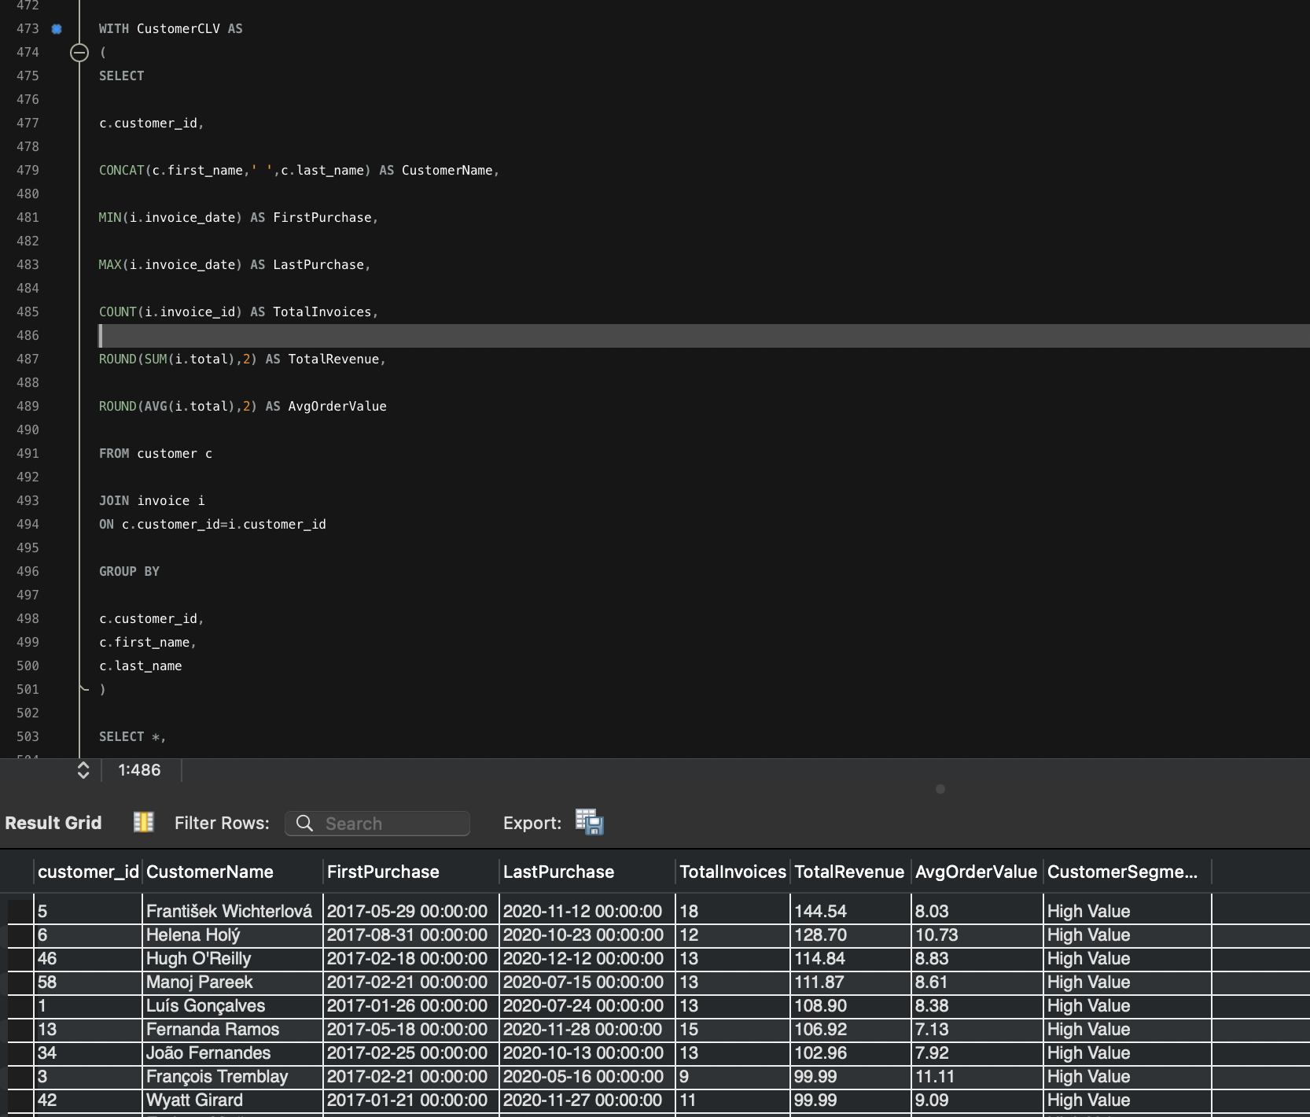

Insights
- High-value customers generate the majority of revenue.
- Long-tenure customers usually spend more.
- Customers with low purchase frequency are more likely to churn.

Recommendations
- Reward High Value customers with exclusive memberships.
- Upsell Medium Value customers.
- Reactivate Low Value customers using promotional offers.

- If data on promotional campaigns (discounts, events, email marketing) is available, how could you measure their impact on customer acquisition, retention, and overall sales?

Final Answer
The Chinook database does not contain promotional campaign data.
If campaign tables were available, the impact could be measured by comparing sales before and after campaigns and evaluating customer acquisition and retention.

Approach
If campaign data existed:
- Compare Sales Before vs After Campaign.
- Calculate Customer Acquisition Rate.
- Calculate Customer Retention Rate.
- Compare Campaign ROI.

- How would you approach this problem, if the objective and subjective questions weren't given?

Final Answer
A structured data analysis methodology would be followed to identify business opportunities without predefined questions.

Approach

Step 1 – Understand the Database
- Review ER Diagram
- Identify Primary Keys
- Understand Relationships

Step 2 – Data Cleaning
- Missing Values
- Duplicate Records
- Data Types
- Referential Integrity

Step 3 – Exploratory Data Analysis (EDA)
Analyze:
- Customers
- Revenue
- Artists
- Albums
- Genres
- Tracks
- Countries

Step 4 – KPI Development
Example KPIs:
- Total Revenue
- Total Customers
- Average Invoice Value
- Top Genres
- Top Artists
- Churn Rate
- Customer Lifetime Value

Step 5 – Business Analysis
Perform:
- Customer Segmentation
- Product Affinity
- Market Analysis
- Revenue Analysis
- Genre Analysis
- Customer Retention

Charts & Tables
- KPI Dashboard
- Revenue Trend
- Top Customers
- Genre Analysis
- Geographic Distribution

- How can you alter the "Albums" table to add a new column named "ReleaseYear" of type INTEGER to store the release year of each album?

Final Answer
The ALTER TABLE statement adds the ReleaseYear column to the album table.

Approach
Use SQL Data Definition Language (DDL).

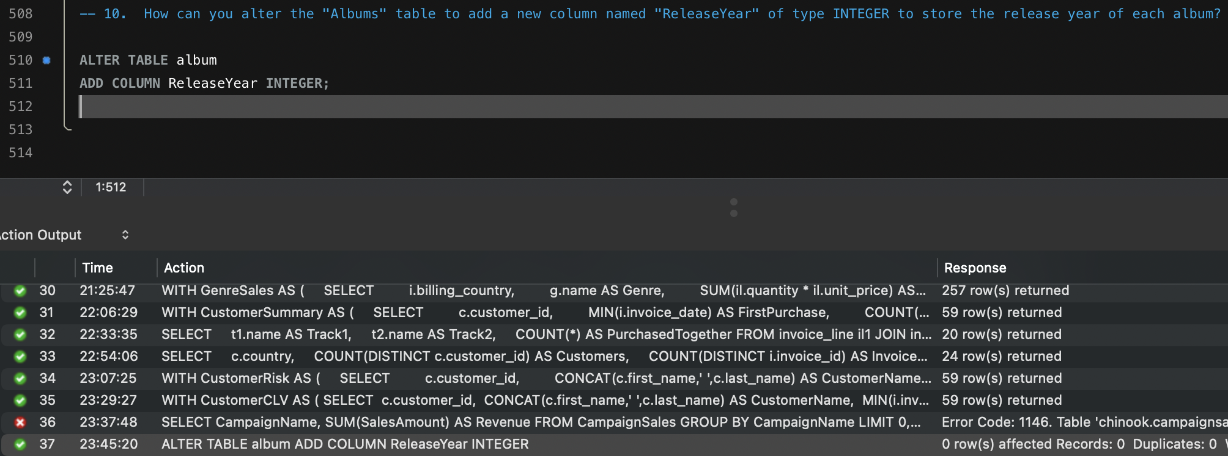

- Chinook is interested in understanding the purchasing behaviour of customers based on their geographical location. They want to know the average total amount spent by customers from each country, along with the number of customers and the average number of tracks purchased per customer. Write an SQL query to provide this information.

Final Answer
This analysis summarizes customer purchasing behaviour by country using average customer spending, customer count, and average tracks purchased.

Approach
- Calculate total spending per customer.
- Calculate total tracks purchased per customer.
- Aggregate the results by country.

Charts & Tables
- Average Spending by Country
- Customers by Country
- Average Tracks Purchased
